**CUSTOM MODELS, LAYERS, AND LOSS FUNCTION WITH TENSORFLOW**

**MODUL 1**

**MODUL 2**

**Custom Loss Functions**

Creating a custom loss function

Coding the huber loss function

Huber loss code walkthrough

**Custom loss hyperparameters and classes**

Adding hyperparameters to custom loss function

Turning loss function into classes

Huber object loss code

**Contrastive loss**

Contrastive loss

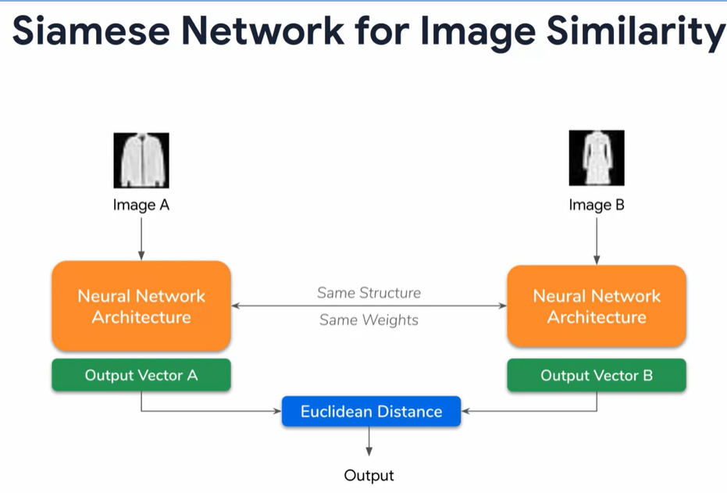

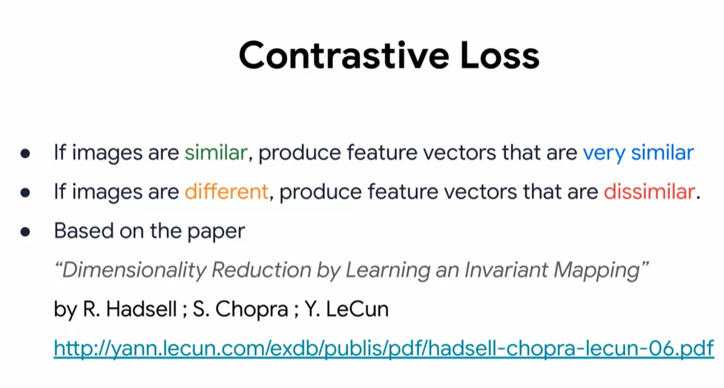

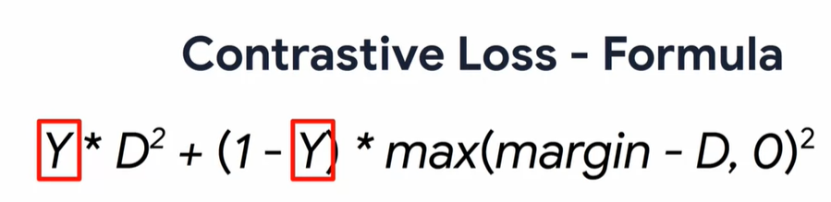

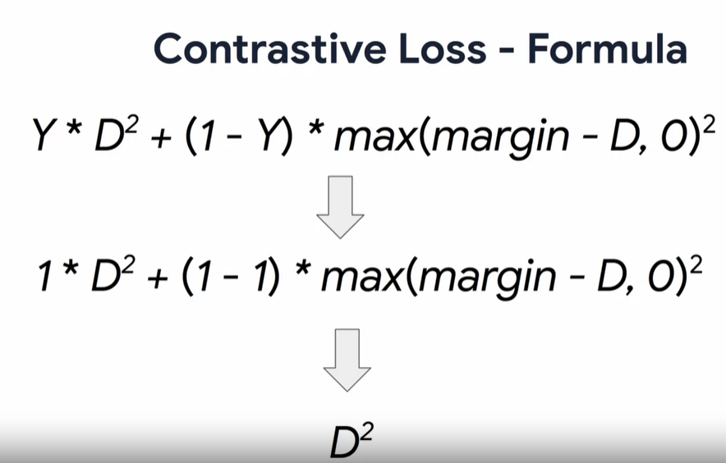

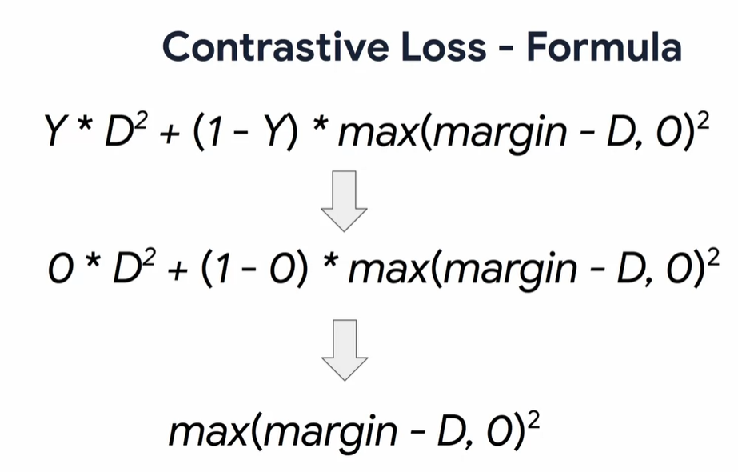

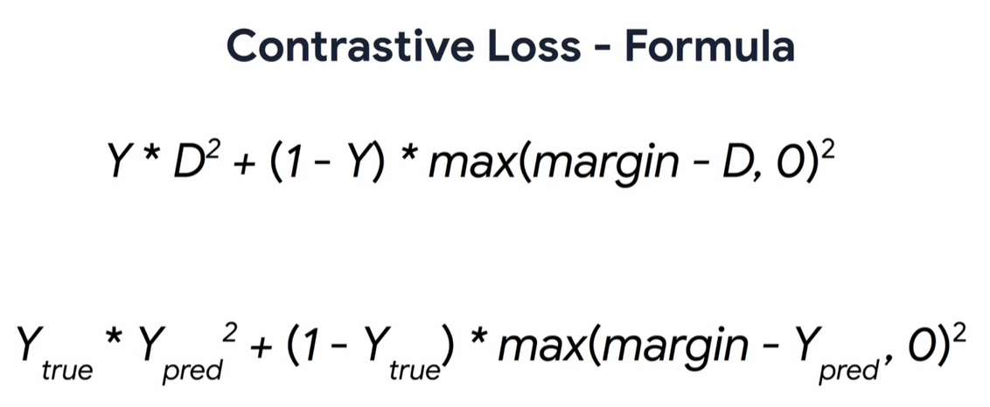

Coding contrastive loss

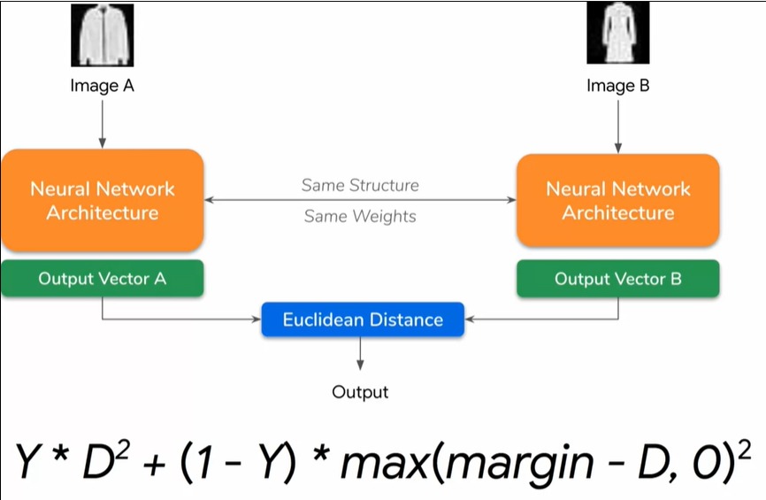

**MODUL 3**

**MODUL 4**

**MODUL 5**